Philip Ward
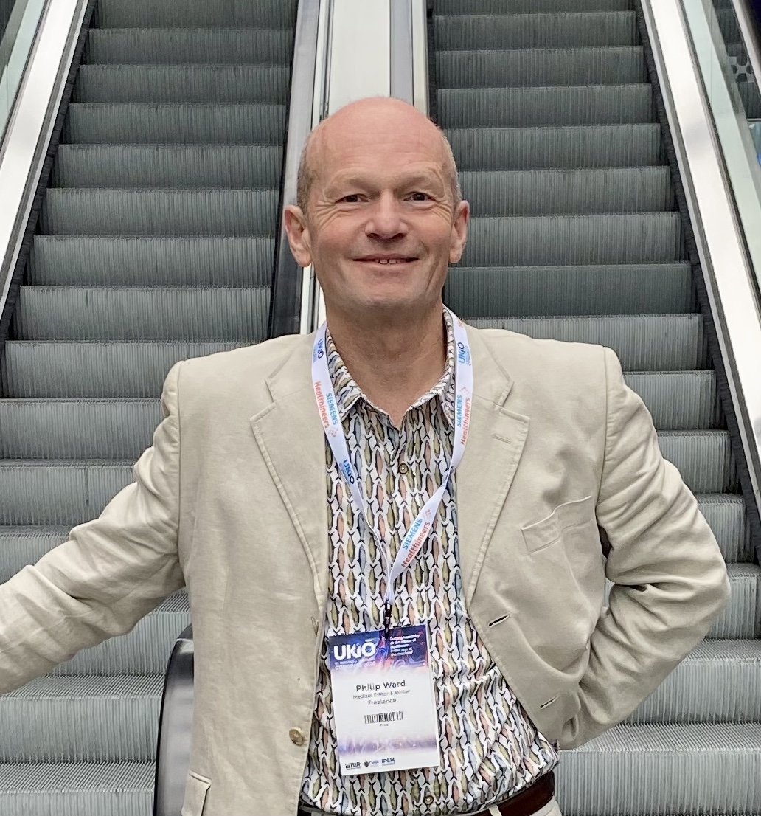

Radiology & Nuclear Medicine Medical Editor
With decades of experience in medical journalism, I specialise in making radiology and nuclear medicine accessible, accurate and engaging.
For more than 15 years, I served as Editor-in-Chief of AuntMinnieEurope.com, alongside 21 years managing the editorial content of the European Congress of Radiology Today newspaper. I work closely with leading experts across the field to deliver timely news, informed insights and authoritative medical content — often to demanding deadlines.
My focus is simple: clear, credible medical journalism that keeps the radiology community informed and supports progress in imaging, nuclear medicine, industry news and medical research.

